Exercise 5: Return Data from a Stored Procedure

USE CompanyDB;
GO
CREATE PROCEDURE GetEmployeeCountByDepartment
@DeptID INT
AS
BEGIN
SELECT
DepartmentID,
COUNT(*) AS TotalEmployees
FROM Employee
WHERE DepartmentID = @DeptID
GROUP BY DepartmentID;
END;
GO
EXEC GetEmployeeCountByDepartment 1;
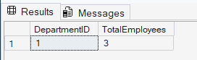

EXEC GetEmployeeCountByDepartment 2;
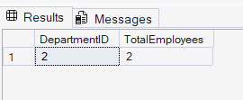
EXEC GetEmployeeCountByDepartment 3;
